` ` ` `
Chapter :1
Introduction
-It is simple game in whicj one bird is moving between different obstacles
-If the bird toches any obstacles yhen the bird will be end and the total score will show in the screen
-Every time the bitd crosses any obstacles the score increase by 1

Project Profile
- Old Process

- Problem Identifier

- Solution for solve the problem
We tested our program in the same way as the developing steps. We tested the overall structure of the game by traversing each interface, and test the single player mode by checking the update of the score and life when bird moves. One difficulty is that we need the user to input NetID to store their score. However, pygame does not contain type-in box to get the keyboard input. Therefore, we added a new interface and transfer the keyboard input to string and draw the string on the screen. Finally, we finished the dual player implementation in a very short period of time because all the fucntionalities are the same as in single player mode.

- New System

We want to create the bird rotating effect when jumping or falling.
Also, we can increase the game difficulity by decreasing the gap between pipes as time goes on.
Finally, we can increase the game difficulity by making pipes move up and down as time goes on.

Chapter : 2

Technical Detail

Environment Specification

HARDWARE SPECIFICATION:
- Minimum CPU-1.7 Ghz
- Minimum RAM-4 GB
- Minimum HDD-160GB
SOFTWARE SPECIFICATION:
- OPEARATING SYSTEM –WINDOWS 2007 (OR ABOVE) with IIS component,Linux
- FONT END-
- BACK END-SQL SERVER/MY SQL

Chapter : 3

MODULE

Chapter :4

Description of Language and data base

What is HTML?
HTML stands for Hyper Text Markup Language.
defines a Markup as:
a set of detailed instructions, usually written on a manuscript to be typeset, concerning style of type, makeup of pages, and the like.
So you can think of HTML as the language used for creating detailed instructions concerning style, type, format, structure and the makeup of a web page before it gets printed (shown to you).
But in the context of web development, we can replace the term ‘printed’ with ‘rendered’ as a more accurate term.

What is CSS?
While HTML is a markup language used to format/structure a web page, CSS is a design language that you use to make your web page look nice and presentable.
CSS stands for Cascading Style Sheets, and you use it to improve the appearance of a web page. By adding thoughtful CSS styles, you make your page more attractive and pleasant for the end user to view and use.

What is JavaScript?
Now, if HTML is the markup language and CSS is the design language, then JavaScript is the programming language.
If you don’t know what programming is, think of certain actions you take in your daily life:
When you sense danger, you run. When you are hungry, you eat. When you are tired, you sleep. When you are cold, you look for warmth. When crossing a busy road, you calculate the distance of vehicles away from you.
Your brain has been programmed to react in a certain way or do certain things whenever something happens. In this same way, you can program your web page or individual elements to react a certain way and to do something when something else (an event) happens.

You can program actions, conditions, calculations, network requests, concurrent tasks and many other kinds of instructions.
You can access any elements through the Document Object Model API (DOM) and make them change however you want them to.
The DOM is a tree-like representation of the web page that gets loaded into the browser.
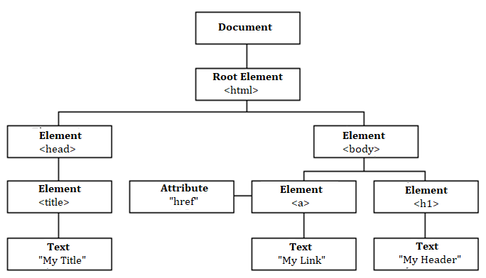

Chapter :5

System Design
Database Tables
E-R DIAGRAM
(1) ER diagram
► ENTITY – RELATIONSHIP MODEL: The ER model is based on the perception of real world as a collection of basic object called Entity and the relationship among the object. A relationship is an association between different entities.
► E-R DIAGRAM: In Entity Relationship diagram relationship between entities can be represented using symbols. It represents over all logical structure of
database .Set of primary component of ERdiagram is:
1. Database Objects
2. Attributes
3. Relationship
4. Various type of Indication.
The symbol and the notation used in ER-diagram are as follow:
► Rectangles: It represents entity sets.

► Ellipses:- It represents attribute.

► Diamond:- It represented entity relationship among the entity sets.

► Line:- Lines links between entity sets and their relationship. It represents attribute.

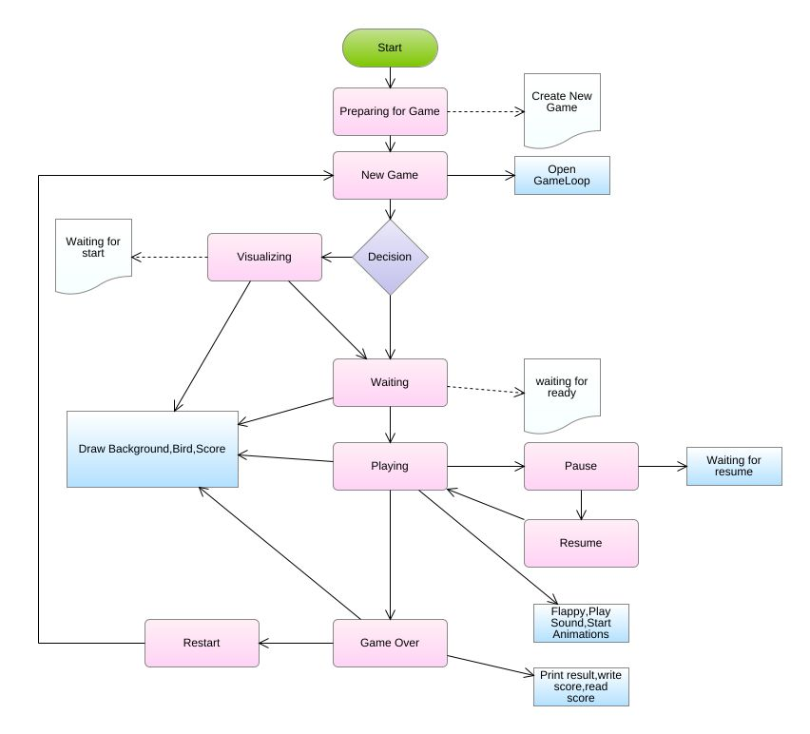

DATAFLOW DIAGRAM:
0-Level DFD
1-Level DFD

Activity Diagram

What is an Activity Diagram?
An activity diagram visually presents a series of actions or flow of control in a system similar to a flowchart or a data flow diagram. Activity diagrams are often used in business process modeling. They can also describe the steps in a use case diagram. Activities modeled can be sequential and concurrent. In both cases an activity diagram will have a beginning (an initial state) and an end (a final state).
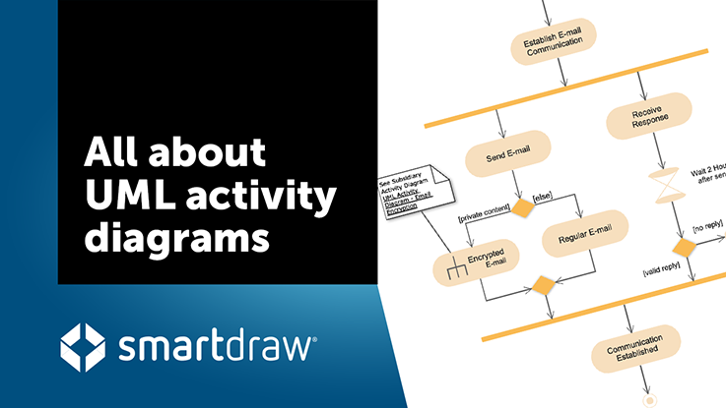
In between there are ways to depict activities, flows, decisions, guards, merge and time events and more. Learn about activity diagram symbols below:

Basic Activity Diagram Notations and Symbols

Initial State or Start Point
A small filled circle followed by an arrow represents the initial action state or the start point for any activity diagram. For activity diagram using swimlanes, make sure the start point is placed in the top left corner of the first column.
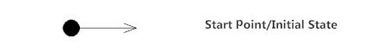

Activity or Action State
An action state represents the non-interruptible action of objects. You can draw an action state in SmartDraw using a rectangle with rounded corners.
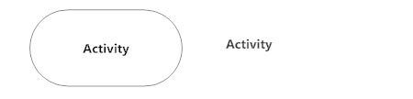

Action Flow
Action flows, also called edges and paths, illustrate the transitions from one action state to another. They are usually drawn with an arrowed line.
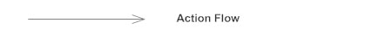

Object Flow
Object flow refers to the creation and modification of objects by activities. An object flow arrow from an action to an object means that the action creates or influences the object. An object flow arrow from an object to an action indicates that the action state uses the object.
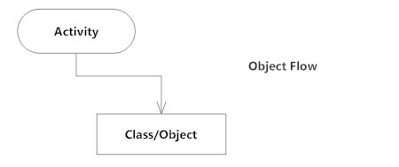

Decisions and Branching
A diamond represents a decision with alternate paths. When an activity requires a decision prior to moving on to the next activity, add a diamond between the two activities. The outgoing alternates should be labeled with a condition or guard expression. You can also label one of the paths "else."
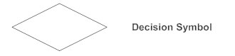

Guards
In UML, guards are a statement written next to a decision diamond that must be true before moving next to the next activity. These are not essential, but are useful when a specific answer, such as "Yes, three labels are printed," is needed before moving forward.
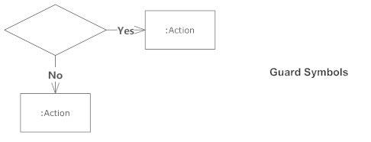

Synchronization
A fork node is used to split a single incoming flow into multiple concurrent flows. It is represented as a straight, slightly thicker line in an activity diagram.
A join node joins multiple concurrent flows back into a single outgoing flow.
A fork and join mode used together are often referred to as synchronization.
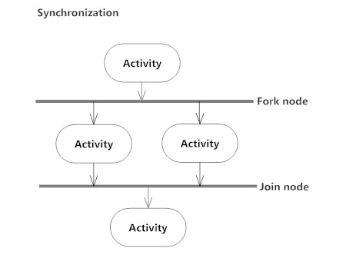

Time Event
This refers to an event that stops the flow for a time; an hourglass depicts it.
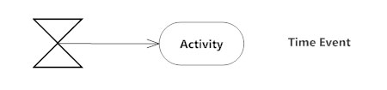

Merge Event
A merge event brings together multiple flows that are not concurrent.
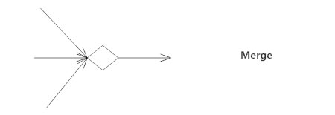

Sent and Received Signals
Signals represent how activities can be modified from outside the system. They usually appear in pairs of sent and received signals, because the state can't change until a response is received, much like synchronous messages in a sequence diagram. For example, an authorization of payment is needed before an order can be completed.
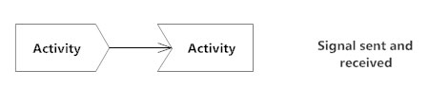

Interrupting Edge
An event, such as a cancellation, that interrupts the flow denoted with a lightning bolt.
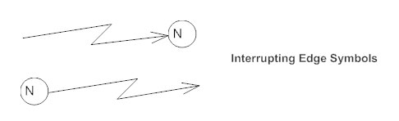

Swimlanes
Swimlanes group related activities into one column.
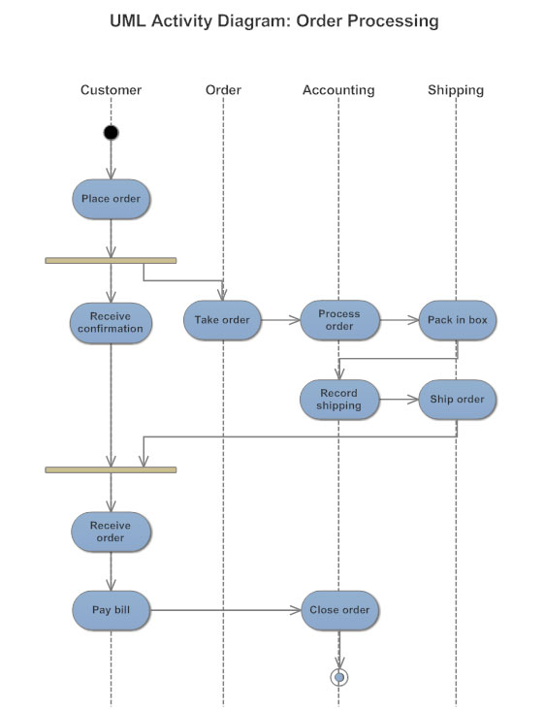

Final State or End Point
An arrow pointing to a filled circle nested inside another circle represents the final action state.
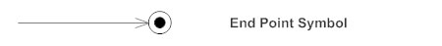

Use case Diagram
USE CASE
ACTIRS : An actor is a direct external user of system .something with abehavior or role.
e.g., a person, another system ,organization.
USE CASEA:The various interaction of actors with a system are quantized case. A collection of related success and failure scenarios,describing actors using the system to
support a goal.

USE CASE DIAGRAM: A system involves a set of use case and a set of actors. Use case diagrams are considered for high level requirement analysis of a system. so when the requirements of a system are analyzed the functionalities are captured in use cases.

Sequence Diagram
⦁ Actors – An actor in a UML diagram represents a type of role where it interacts with the system and its objects. It is important to note here that an actor is always outside the scope of the system we aim to model using the UML diagram.

Figure – notation symbol for actor
We use actors to depict various roles including human users and other external subjects. We represent an actor in a UML diagram using a stick person notation. We can have multiple actors in a sequence diagram.
For example – Here the user in seat reservation system is shown as an actor where it exists outside the system and is not a part of the system.

⦁ Lifelines – A lifeline is a named element which depicts an individual participant in a sequence diagram. So basically each instance in a sequence diagram is represented by a lifeline. Lifeline elements are located at the top in a sequence diagram. The standard in UML for naming a lifeline follows the following format – Instance Name : Class Name

We display a lifeline in a rectangle called head with its name and type. The head is located on top of a vertical dashed line (referred to as the stem) as shown above. If we want to model an unnamed instance, we follow the same pattern except now the portion of lifeline’s name is left blank.
Difference between a lifeline and an actor – A lifeline always portrays an object internal to the system whereas actors are used to depict objects external to the system. The following is an example of a sequence diagram:

⦁ Messages – Communication between objects is depicted using messages. The messages appear in a sequential order on the lifeline. We represent messages using arrows. Lifelines and messages form the core of a sequence diagram.
Messages can be broadly classified into the following categories :

Chapter :6

System Implementation
Screen Shots (Optinal)
Testing

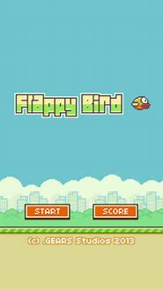

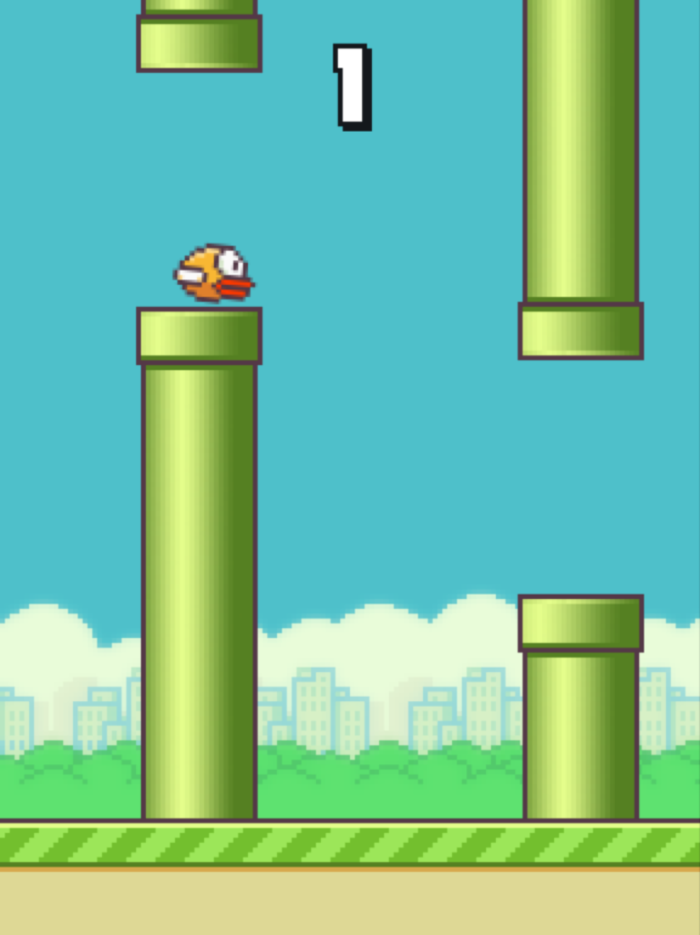

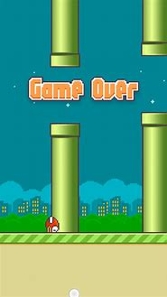

Chapter :7
Advantages and Disadvantages

Chapter :8
Future Enhancement

Reference

